Polinomio de Newton – Gregory (General – no necesariamente equiespaciados)

Progresivo:
$$P_{n}\left(x\right)=a_{0}+a_{1}\left(x-x_{0}\right)+a_{2}\left(x-x_{0}\right)\left(x-x_{1}\right)+⋯+a_{n}\prod_{i=0}^{n-1}{\left(x-x_{i}\right)}$$

$a_{i}=f[x_{0},x_{1},...,x_{i}]$ Diferencia dividida progresiva de orden i

$f[x_{i},x_{i+1}]=\frac{f_{i+1}-f_{i}}{x_{i+1}-x_{i}}$ Diferencia dividida progresiva de orden 1

$f[x_{i},x_{i+1},x_{i+2}]=\frac{f[x_{i+1},x_{i+2}] - f[x_{i},x_{i+1}]}{x_{i+2}-x_{i}}$ Dif. dividida progresiva de orden 2

$$P_{n}\left(x\right)=f\left[x_{0}\right]+f\left[x_{0},x_{1}\right]\left(x-x_{0}\right)+f\left[x_{0},x_{1},x_{2}\right]\left(x-x_{0}\right)\left(x-x_{1}\right)+⋯+f\left[x_{0},x_{1},…,x_{n}\right]\prod_{i=0}^{n-1}{\left(x-x_{i}\right)}$$

Ejemplo: Hallar el polinomio de menor grado que interpola los siguientes puntos:
X_{i} | F(x_{i})
1 | 1
3 | 3
4 | 13
5 | 37
7 | 151

X_{i} | F(x_{i}) | 1ª Dif. Div. | 2ª Dif. Div. | 3ª Dif. Div. | 4ª Dif. Div.
1 | 1
 |  | 1
3 | 3 |  | 3
 |  | 10 |  | 1
4 | 13 |  | 7 |  | 0
 |  | 24 |  | 1
5 | 37 |  | 11
 |  | 57
7 | 151

$a_{0}=1$
$$a_{1}=1 \\ a_{2}=3 \\ a_{3}=1 \\ a_{4}=0$$

$$P_{4}\left(x\right)=a_{0}+a_{1}\left(x-x_{0}\right)+a_{2}\left(x-x_{0}\right)\left(x-x_{1}\right)+a_{3}\left(x-x_{0}\right)\left(x-x_{1}\right)\left(x-x_{2}\right)+a_{4}\left(x-x_{0}\right)\left(x-x_{1}\right)\left(x-x_{2}\right)\left(x-x_{3}\right)$$

$$P_{4}(x) = 1 + 1·(x-1) + 3·(x-1)(x-3) + 1·(x-1)(x-3)(x-4)$$

$$P(x) = x³ - 5x² + 8x - 3$$

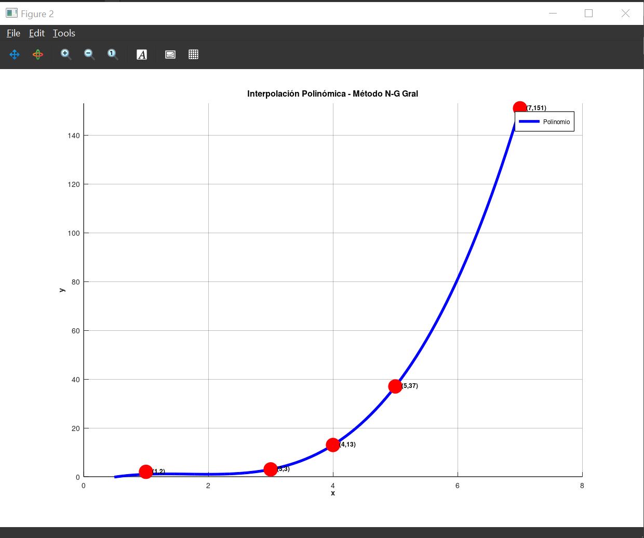

Polinomio de Newton – Gregory (REGRESIVO)
$$P_{n}\left(x\right)=f\left[x_{n}\right]+f\left[x_{n},x_{n-1}\right]\left(x-x_{n}\right)+f\left[x_{n},x_{n-1},x_{n-2}\right]\left(x-x_{n}\right)\left(x-x_{n-1}\right)+⋯+f\left[x_{n},x_{n-1},…,x_{0}\right]\prod_{i=0}^{n-1}{\left(x-x_{n-i}\right)}$$

$f[x_{n},x_{n-1}]=\frac{f_{n-1}-f_{n}}{x_{n-1}-x_{n}}$ Diferencia dividida regresiva de orden 1
$f[x_{n},x_{n-1},x_{n-2}]=\frac{f[x_{n-1},x_{n-2}] - f[x_{n},x_{n-1}]}{x_{n-2}-x_{n}}$ Dif. dividida progresiva de orden 2

X_{i} | F(x_{i})
1 | 1
3 | 3
4 | 13
5 | 37
7 | 151

X_{i} | F(x_{i}) | 1ª Dif. Div. | 2ª Dif. Div. | 3ª Dif. Div. | 4ª Dif. Div.
1 | 1
 |  | 1
3 | 3 |  | 3
 |  | 10 |  | 1
4 | 13 |  | 7 |  | 0
 |  | 24 |  | 1
5 | 37 |  | 11
 |  | 57
7 | 151

$$P_{4}\left(x\right)=a_{0}+a_{1}\left(x-x_{4}\right)+a_{2}\left(x-x_{4}\right)\left(x-x_{3}\right)+a_{3}\left(x-x_{4}\right)\left(x-x_{3}\right)\left(x-x_{2}\right)+a_{4}\left(x-x_{4}\right)\left(x-x_{3}\right)\left(x-x_{2}\right)\left(x-x_{1}\right)$$

$$P\left(x\right)=151+57\left(x-7\right)+11\left(x-7\right)\left(x-5\right)+1\left(x-7\right)\left(x-5\right)\left(x-4\right)+0\left(x-7\right)\left(x-5\right)\left(x-4\right)\left(x-3\right)$$

$$P(x) = 151 + 57x - 399 + 11x² - 132x + 385 + x³ - 16x² + 83x - 140$$
$$P(x) = x³ - 5x² + 8x - 3$$

Polinomio de Newton – Gregory (Puntos Equidistantes)
$$P_{n}\left(x\right)=a_{0}+a_{1}\left(x-x_{0}\right)+a_{2}\left(x-x_{0}\right)\left(x-x_{1}\right)+⋯+a_{n}\prod_{i=0}^{n-1}{\left(x-x_{i}\right)}$$
$$a_{i}=\frac{Δ^{k}y_{i}}{k! h^{k}}$$

$$Δ^{k}y_{i}=Δ^{k-1}y_{i+1}-Δ^{k-1}y_{i} \text{para }k≥1$$

$$P_{n}\left(x\right)=y_{0}+\frac{Δy_{0}}{1! h}\left(x-x_{0}\right)+\frac{Δ^{2}y_{0}}{2! h^{2}}\left(x-x_{0}\right)\left(x-x_{1}\right)+⋯+\frac{Δ^{n}y_{0}}{n! h^{n}}\prod_{i=0}^{n-1}{\left(x-x_{i}\right)}$$

X_{i} | F(x_{i})
0 | -3
1 | 1
2 | 1
3 | -3

X_{i} | F(x_{i}) | Δy | Δ²y | Δ³y
0 | -3
 |  | 4
1 | 1 |  | -4
 |  | 0 |  | 0
2 | 1 |  | -4
 |  | -4
3 | -3

$$a_{0}=y_{0}=-3$$
$$a_{1}=\frac{Δy_{0}}{1!}=\frac{4}{1}=4$$
$$a_{2}=\frac{Δ^{2}y_{0}}{2!}=\frac{-4}{2}=-2 \\ a_{3}=\frac{Δ^{3}y_{0}}{3!}=\frac{0}{6}=0 \\ P\left(x\right)=-3+4\left(x-0\right)-2\left(x-0\right)\left(x-1\right)+0\left(x-0\right)\left(x-1\right)\left(x-2\right)$$
$$P(x) = - 2x² + 6x - 3$$

